Adara Press mod. 52

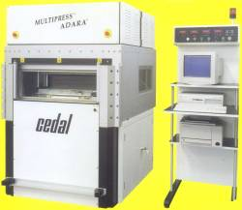

The ADARA hot press model 52 is a realization of a revolutionary technology for laminating multilayers and base materials. It has an adjustable single opening where a stack of product is laminated. The stack is heated directly through the continuous copper foil as a result of Joule effect. The A.C. main supply is transformed into a low D.C. voltage high current generator and by controlling the current value the heat is transferred to the prepreg with great thermal exchange efficiency. The high energy saving is moreover assured by the power consumption during the press cycle only (no tank of hot oil full day is used). The copper foil may be the outerlayer in case of multilayer pressing as well as the copper clad in case of base thin laminate pressing. In the last case the very thin laminates with very thin copper clad are easily pressed without scratches due to wrinkles: this is obtained by the patented way the laminate stack is prepared.

